**Objective**

In this checkpoint, we have the following relational model created. Now we must insert data into the different tables using DML language:

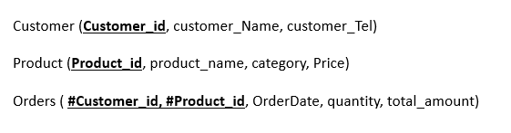

**Instructions**

Write SQL commands to insert the following rows into the corresponding tables

